Purpose & Scope

To establish a procedure for loading and final inspection of orders.

Reference Documents

QSP 8.1 Product Identification QSP 9.1 Order Fulfillment
QSP 13.1 Control of Nonconforming Product

Process Flow
Shift Supervisor, 3.1
Damaged material?
Yes
No
Missing material?
No
B
Yes
A
If possible, replace material per QSP 9.1
Notify Supervisor and place damaged material in hold location.
Receives paperwork, locates material, and loads on correct truck or provides to customer, verifying all items are loaded per order and there is no visually apparent damage.
Reviews orders for completeness and accuracy and assigns them to appropriate Material Handler for loading.
Process Test Reports as required by Orders and attach to customer copy of order.
Lead or Administrator
Shift Supervisor, 3.2
Lead or Administrator
Material Handler 3.3

Material Handler 3.4

Material Handler 3.5

Material Handler 3.6

A
Shortage Tag BO001
Is missing material available?
Yes
No
B
B
Signed Delivery/Pickup ticket
Deliver or Load Customer’s vehicle, obtain Customer’s signature, name and date on Delivery/Pickup ticket. Material Handler must
sign their name as a requirement in the designated area after loading a customer. Return completed paperwork to designated areas.
Process backorders per QSP 9.1.
Assign personnel to process material per QSP 9.1. If
completed, remove shortage tag and forward material and order to Material Handler to load material.
Unless already attached, attaches one pink Shortage Tag (BO001) for each line item to be backordered near the bottom of the paperwork referencing that line item (it should extend beyond the bottom of the page for easy visibility), fill out and sign. Forwards to Shift Supervisor, Lead or Warehouse Administrator.
Note reasons for missed orders and backorder items and email this information to Shipping Supervisor, Inside Sales, Sales Manager, Purchasing and GM.
Print Delivery/Pickup paperwork.
Review orders for changes to quantities. Signs paperwork when complete and forwards to Shipping Office or Supervisor to record in the business system.

Material Handler 3.7

Shift Supervisor 3.8
Lead or Administrator

3.9

Material Handler, 3.10
Supervisor or Lead
Shift Supervisor, 3.11
Lead or Administrator
Shift Supervisor, 3.12
Lead or Administrator

Driver/ 3.13
Material Handler

Procedure Statements

  - For C.O.D. transactions – collect payment per Company Policy at time of delivery or prior to loading at Will Call.

  - Test Reports or Certificates of Conformance (C of C’s) are provided when requested on Orders. Test reports and C of C’s are only provided as specified in QSP 8.1.

  - The Puller verifies that the material matches work order requirements: quantity, description, size, number of pieces.

  - If the customer does not want to wait for test reports, fax or mail to customer.

  - C of C’s only available per customer request.

  - Pullers load accepted orders onto the customer’s vehicle and obtain the customer’s signature on the proof of delivery copy of the paperwork. Sign and date paperwork and return it to Customer Service personnel for final processing.

  - While any type of order or transfer is being processed, use Stock Problem Tags as needed.

Risks

- Establishment of criteria for product acceptance (measurement, inspection, and verification).
- Availability of equipment (tools, workstations, material handling etc.).
- Ensuring the correct information for supplier control, inspection and paperwork verification.
- Maintaining proper records to provide evidence that product qualifications meet all requirements e.g. inspections, and C of C’s.
- Controlling unintended changes to requirements, processes, methods, and the schedule.
- Proper accompanying documentation at the point of delivery e.g. C of C, delivery notes, shipping notes, and handling instructions.
- Segregation of nonconforming products, use of dedicated areas, identification to show nonconforming status (labels and markings).
- Appropriate lighting to enable safe work in and around the truck beds.
- Safety awareness training when walking on uneven work surfaces in the truck beds.
- Training to prevent product damage during loading/strapping and transportation.

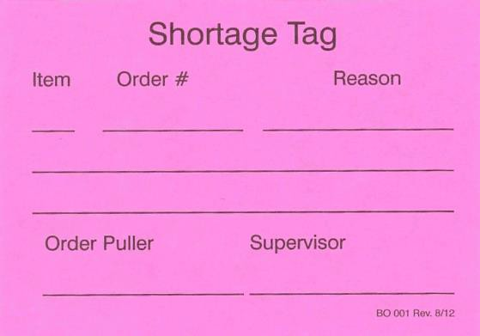
Applicable Records

Shortage Tag BO001

Personnel to be Trained

Warehouse Manager Shift Supervisor Warehouse Lead Warehouse Administrator Material Handler

